Great — since this is for your Instructional Design portfolio, and based on the PDF’s guidance (360° immersive learning, AI-powered workflow, microlearning, simulation/branching), here are 7 strong, portfolio-worthy eLearning course topic options you can choose from.
I’ll then develop the entire course blueprint with hyper-detailed steps (colors, fonts, triggers, JS, layout, scenario flow, AI asset generation prompts, Storyline setup, and more).

✅ TOPIC OPTIONS (Choose ONE)
Each one follows the ideas in your PDF: real-world problem, spatial awareness, 360° scenario, AI integration.

1. Emergency Response: Fire Safety Inspection in a Workplace
Learners explore a 360° office environment, identify hazards, choose actions, and see consequences.
Why powerful: Combines spatial scanning, hotspot decision-making, branching, microlearning, and AI voiceover.

2. Retail Store Customer Escalation Scenario
Navigate a 360° retail floor, handle an upset customer, choose de-escalation strategies, and check policies.
Why powerful: Strong behavioral scenario + emotional intelligence + branching.

3. Hospital Patient-Room PPE Compliance
Learner examines a 360° hospital room and chooses correct PPE steps based on patient condition.
Why powerful: Spatial sequencing + safety workflow + compliance.

4. Manufacturing Plant: Machine Lockout–Tagout (LOTO) Procedure
Explore the floor, inspect a machine, and choose the correct lockout sequence.
Why powerful: High demand for safety & mechanical training + spatial environment + sequential logic.

5. University Campus Cybersecurity Walkthrough
Navigate a 360° office and identify unsecured devices, phishing signs, and risky behaviors.
Why powerful: Corporate cybersecurity is ALWAYS in demand.

6. Airline Ground Crew Safety Check
Learners examine a 360° airport tarmac layout and identify hazards, follow the sequence, and make decisions.
Why powerful: Rare, high-value scenario + spatial awareness.

7. Hotel Housekeeping Excellence Scenario
Learner explores a 360° hotel room, identifies issues, and chooses best-practice housekeeping standards.
Why powerful: Hospitality companies love immersive scenario training.

⭐ What Happens Next
Once you choose a topic, I will deliver:

🎨 1. Hyper-detailed visual style guide
- Exact color palette with HEX codes
- Font pairings (Google fonts or free alternatives)
- Button styles, layouts, spacing, padding, alignment rules
- Icon styles and imagery guidelines

📚 2. Full storyboard
- Scene-by-scene screen layouts
- On-screen text
- Narration script
- 360° hotspots
- Feedback variants
- Branching map
- Use of AI-generated content (images, voiceover, avatars)

🎮 3. Interaction & Trigger Logic (Step-by-step)
- All Articulate Storyline triggers
- Variables (T/F, text, number)
- Conditions
- Visited states
- JS snippets to use (timer, randomization, custom scoring)

🔧 4. Storyline Build Instructions
- Slide masters
- Feedback masters
- Layers
- Hotspot setup
- Progress markers
- Custom results screen

🤖 5. AI Workflow (Ultra-detailed)
- Prompts for Midjourney/DALL·E for 360° environment creation
- Prompts for voiceover (ElevenLabs, PlayHT)
- Prompts for rewriting content
- How to use AI to accelerate chunking, feedback, and branching

🧩 6. Scenario + Branching Model
- Choices
- Consequence paths
- Reward/penalty logic
- Adaptive learning variation

👉 Which ONE topic do you want me to build the full hyper-detailed course for?
(You can pick a number or paste the topic.)
If you want, I can also suggest which one is strongest for L&D hiring managers.
Perfect. EV Charging Station Safety & Setup is an excellent portfolio topic — it’s modern, technical, high-demand, and fits beautifully with a 360° immersive, AI-driven scenario.
Before I start building the full hyper-detailed course (colors, fonts, JS, triggers, layouts, Storyline build, AI prompts, branching), I need one quick clarification so I can tailor the whole experience.

✔ Quick Question (Choose One Scenario Direction)
For EV Charging Station Safety & Setup, which direction do you prefer?

OPTION A — “Public EV Charging Station Technician Training”
Learner is a field technician performing:
- Site inspection
- Checking electrical panel load
- Verifying grounding
- Setting up charger
- Testing for faults
- Ensuring pedestrian safety
Learner navigates a 360° environment (parking lot + charging station), finds hazards, and follows the setup sequence.
This is the strongest for corporate/technical ID portfolios.

OPTION B — “Customer Safety at a Public EV Charging Station”
Learner is a user who must:
- Detect damaged cables
- Know when NOT to charge
- Handle emergency stop
- Understand water exposure risks
- Report unsafe equipment
Great for microlearning + consumer education.

OPTION C — “EV Charger Setup inside a Residential Garage”
Learner evaluates:
- Panel capacity
- Conduit routing
- Placement & ventilation
- Safe distances from water
- Faulty installation risks
Good for construction/technical compliance audiences.

OPTION D — “EV Charging Station Troubleshooting Scenario”
Learner diagnoses:
- Ground fault
- Overheating
- Power drop
- Loose connections
- Faulty cable
- Charging interruption
Excellent for decision-based branching with consequences.

✔ Tell me which option you choose: A, B, C, D — or a combination.
Once you choose, I’ll deliver Part 1: The Ultra-Detailed Visual Style Guide followed by:
- Storyline layout
- Scenario maps
- Hotspot interactions
- JS code
- Color palette
- Font hierarchy
- AI prompts
- Full storyboard
- Trigger-by-trigger build steps
Ready when you are!
Nice — good choice. Below I’ve pulled together authoritative research resources, standards, manuals, and practical guides for residential EV charger setup (Option C) and compared how well established resources are across the other scenario options. I checked regulator guidance, international standards, and manufacturer installation manuals so you’ll have a solid evidence base for your Storyline course content and compliance notes.

Quick verdict (TL;DR)
- Yes — there are established, authoritative standards and many manufacturer installation manuals for residential EV charger installation. Use IEC 61851 / IEC 62196, national codes (NEC Article 625 in the U.S.), and Indian standards / government guidelines as the backbone. (EV Engineering Online)
- Manufacturer manuals (Tesla, ChargePoint, etc.) provide practical step-by-step installation and safety warnings you can quote or show screenshots from (for portfolio: cite and link). (Tesla)
- India-specific policy/standards exist (Ministry of Power consolidated guidelines; IS/ BIS catalog like IS 17017 and AIS standards) — so you can include local compliance notes. (Power Ministry of India)

Authoritative STANDARDS & REGULATIONS (must-read)
- IEC 61851 (EV charging system — general requirements) — explains modes of charging, safety, and control pilot signalling; essential for conductive charging behavior and safety requirements. (EV Engineering Online)
- IEC 62196 (Plugs, socket-outlets, vehicle connectors) — connector types (Type 1 / Type 2 / DC combos) and basic mechanical/electrical characteristics. Useful for connector compatibility content. (Wikipedia)
- NEC (National Electrical Code) — Article 625 (USA) — how residential installations are to be sized, overcurrent protection, wiring, and equipment installation rules (critical if you include US-focused compliance slides). (LsiCloud)
- AIS / Indian EV-related standards & BIS / IS 17017 — India’s standards and harmonisation of charging infrastructure (connector and EVSE standards) — include in your India-specific compliance module. (Ministry of Road Transport & Highways)
- Ministry of Power — Charging Infrastructure Guidelines (India) — consolidated government guidance for siting and quality/safety expectations (useful for public/residential policy notes). (Power Ministry of India)

Manufacturer INSTALLATION MANUALS & GUIDES (practical how-tos)
These are excellent for 360° hotspots where learners inspect cable routing, mounting options, conduit entry, and breaker sizes.
- Tesla Wall Connector — Installation Manual & Support (wall-mounting options, conduit entry, planning checklist). (Tesla)
- ChargePoint Home Flex — Installation Guide (CPH50) — clear electrician-facing steps, amperage options, warnings. (ChargePoint)
- Emporia / Other consumer EV charger manuals — practical examples of grounding, indoor/outdoor use, bonding. (Emporia Energy)
Use manufacturer PDFs for realistic “Find the issue” slides (e.g., show a mounting that violates the manual, ask learner to pick the fix).

India-specific & Policy Documents (important since you’re in India)
- Charging Infrastructure for Electric Vehicles — Guidelines (Ministry of Power) — consolidated rules, performance, charging point siting, and obligations. Good to quote for local compliance slides. (Power Ministry of India)
- AIS/IS / BIS standards listing (IS 17017 and related parts) — national standard references for EVSE & connectors; use to justify compliance checks. (e-Amrit)
- Recent press / updates on BIS standardization work (BIS publishing related standards). (Press Information Bureau)

Practical learning resources, tutorials & FAQs
- Manufacturer support pages (Tesla support install, ChargePoint resources). These often include videos and checklists. (Tesla)
- Industry explainers on IEC / connector types (summaries and comparisons — e.g., IEC 62196 overviews). (Wikipedia)
- Installer checklists / whitepapers — many vendors publish one-page checklists (search vendor pages for PDF checklists).

Scholarly/technical reading (optional, for deeper module)
Search Google Scholar or IEEE for implementation/safety studies on residential EV charger installations and failure modes (ground-faults, ingress, overheating). If you want, I can pull specific academic papers and summarize key findings for your scenario.

Are there already “manuals” for residential garage EV charger setup?
Yes. There are two tiers of authoritative manuals you can use in your course:
- Standards & regulations (IEC 61851, IEC 62196, NEC Article 625, AIS/BIS/IS17017) — define how equipment should behave and safety/compliance requirements. Use these as the legal/technical backbone in your course. (EV Engineering Online)
- Manufacturer installation manuals (Tesla, ChargePoint, Emporia, etc.) — practical, step-by-step instructions (mounting, conduit entry, breaker sizing, commissioning). These are plentiful and very useful for realistic, actionable course content. (Tesla)
If you want to include verbatim extracts/screenshots from manufacturer manuals in a public portfolio, we should ensure proper attribution and respect any copyright (quote short excerpts and link to original manuals).

Which of the earlier scenario topics has the most established resources?
(You asked earlier to compare topics A–D — short comparison)
- Option C — Residential Garage Setup (your choice): Very well supported. Strong manufacturer manuals, national standards, and lots of practical installer guidance. Good for portfolio because you can cite real manuals and standards. (Tesla)
- Option A — Public EV Charging Station Technician: Also very well supported by government siting guidance, grid-integration rules, and public CPO documentation; plus procurement specs — strong for policy-level content. (Power Ministry of India)
- Option D — Troubleshooting: Technical fault-analysis resources exist but are scattered (manufacturer troubleshooting guides, technical service bulletins). Fewer high-level standards but many vendor service docs. (Emporia Energy)
- Option B — Customer Safety Microlearning: Plenty of consumer-facing content and safety leaflets exist from utilities and vendors, but fewer technical standards (because it’s behaviour-focused).
Bottom line: Residential installation (C) and Public technician (A) are the best supported by authoritative standards + practical manuals. Both will make strong portfolio pieces — C gives you explicit hands-on installer steps and close-ups (good for 360° hotspots); A gives you systems & grid-context which is great for demonstrating governance & technical depth. (Power Ministry of India)

Recommended primary documents to download & review first (priority order)
- Ministry of Power — Charging Infrastructure Guidelines (India) — consolidated PDF. (Power Ministry of India)
- IS / BIS EV charging standards index (IS 17017 parts) — BIS / e-Amrit page. (e-Amrit)
- IEC 61851 overview (general requirements for EV charging) — good summary article & standard reference. (EV Engineering Online)
- NEC Article 625 summary / PDF (if you plan an international module). (LsiCloud)
- Tesla Wall Connector installation manual (example manufacturer PDF). (Tesla)
- ChargePoint Home Flex installation guide (example consumer-level, electrician-facing PDF). (ChargePoint)

Next (exactly what I can do now)
I can immediately:
- Download/read the specific manuals you want included (e.g., Tesla, ChargePoint) and extract:
  - Key do/don’t checks for hotspot interactions.
  - Exact checklist items for a residential pre-install inspection slide.
- Build the hyper-detailed visual style guide + Storyline blueprint for Option C: Residential Garage Setup, including:
  - Color palette, fonts, iconography (HEX & Google Fonts)
  - Slide masters, layers, hotspot layouts for 360° garage scene
  - All Articulate Storyline triggers & variables + JS snippets (timer, custom scoring, checklist persistence)
  - AI prompts for generating 360° visuals, voiceovers, and scenario images
  - Storyboard, scripts, branching map, and assessment rubrics
Would you like me to:
A. Start by downloading & extracting action-items from Tesla + ChargePoint manuals and the Ministry of Power guidelines (I’ll use those to seed the hotspot checklist and compliance checks)?
B. Or skip straight to building the visual style guide + Storyline blueprint using the standards list above?
Pick A or B (or say “both” — I’ll combine them).
Great — I pulled the core manuals and government guidelines and extracted a practical, installer-facing action checklist you can drop straight into 360° hotspot interactions and pre-install inspection slides for the Residential Garage EV Charger Setup module (Option C). I also show which authoritative docs back each checklist item and whether a dedicated “manual” exists. Everything below is ready-to-use for Storyline hotspots, feedback branches, and compliance callouts.

What I fetched (primary sources)
- Tesla Wall Connector — installation manuals & install resources. (Tesla)
- ChargePoint Home Flex installation guide & resources. (ChargePoint)
- Ministry of Power — “Charging Infrastructure for Electric Vehicles” (India consolidated guidelines, updated). (Power Ministry of India)
- National/International standards and code guidance (IEC 61851 series; AIS 138 / AIS AC/DC standards; NEC Article 625 & summaries). (Iteh Standards)
Bottom line: Manufacturer installation manuals + national/international standards are available and are the best primary evidence base for your course. Use standards (IEC/NEC/AIS/BIS) for “must” compliance rules and vendor manuals for step-by-step, realistic installation checks. (Iteh Standards)

Extracted, actionable INSTALLATION & SAFETY CHECKLIST (ready for 360° hotspot items)
Use each line below as either a hotspot inspection prompt (Learner clicks and must choose Pass / Fail / Fix) or source-based feedback text.

1) Pre-installation planning & permits
- Verify local permit/inspection requirements and that a licensed electrician will perform electrical connections. (Course copy: “Check permit on file / electrician licensed”.) (ChargePoint)
- Confirm service panel capacity and whether an additional dedicated circuit / panel upgrade is required. (Collect meter/panel photos in scenario.) (LsiCloud)

2) Circuit sizing & breaker selection
- Confirm charger amperage chosen (e.g., 16–50 A for many Level 2 home units) and size branch-circuit breaker accordingly (manufacturer-specified). Add a Storyline variable for “selected amperage” to validate learner choice. (ChargePoint)
- Ensure proper conductor size (copper/insulation type) per current code and manufacturer table — show sample table in hotspot. (ChargePoint)

3) Dedicated circuit & labeling
- Charger must be on a dedicated circuit. Label breaker “EV Charger — Device” and include a visible nameplate close to panel. (Hotspot: mark missing label = fail). (Tesla)

4) Grounding & bonding
- Verify proper equipment grounding conductor and bonding per the manual and local code; ensure the ground electrode and grounding conductor are intact and continuous. (Hotspot: show loose ground screw — fail). (Tesla)

5) RCD/GFCI / Earth Leakage Protection
- For residential indoor/outdoor locations, ensure protective RCD/GFCI or equivalent ground-fault protection is installed per manufacturer and NEC/local standards. (Hotspot: simulate trip test). (ChargePoint)

6) Location & clearance
- Charger mounting height, clearances from doorways, water sources, and combustible material per manual (show measured tape in scene). Include min clearances in hotspot feedback. (Tesla)

7) Ingress Protection & Indoor/Outdoor rating
- Verify IP/NEMA rating is appropriate for garage (potential humidity/water) and outdoor exposure if applicable. (Hotspot: show charger with damaged gasket — record IP violation). (ChargePoint)

8) Conduit entry & cable routing
- Conduit must be routed to avoid sharp bends, and service wiring must be protected from abrasion. Verify grommets, clamps, and weatherproofing for exterior entries. (Hotspot: show exposed wiring into drywall). (Tesla)

9) Cable length, kink/damage inspection & tethering
- Inspect charging cable for damage, kinks, or exposed conductors; verify tethering and storage bracket provided/installed correctly. (Hotspot: damaged cable = mandatory fail). (ChargePoint)

10) Surge protection & overcurrent devices
- Confirm recommended surge protective device (SPD) is installed per manufacturer/utility guidance or note where it’s recommended. (Provide optional “install SPD” branch). (Iteh Standards)

11) Ventilation & heat sources
- If charger or battery packs are near heat sources (furnace, hot water heater), check recommended clearance and ventilation; flag heat sources inside garage. (Hotspot: close proximity to heater = warning). (Tesla)

12) Isolation / emergency shutoff & signage
- Ensure emergency disconnect location (as required by code/utility) is identified and labeled (if required by local code). Provide clear instructions about the EVSE emergency stop and vehicle isolation. (Power Ministry of India)

13) Commissioning & functional tests
- Perform and document commissioning tests: verify voltage at receptacle, insulation resistance (if required), operation of pilot/control signals, GFCI test, and initial charge session while monitoring. (Hotspot: student must order the test steps correctly). (Tesla)

14) Documentation & warranty registration
- Record serials, installation photos, commissioning results, and advise homeowner on warranty registration & app setup (e.g., Tesla app pairing). (Hotspot: forget to record serial = graded deduction). (Tesla Energy Library)

15) Environmental & water ingress checks
- Do not install within specified distance of water sources; verify drainage and gasket condition on exterior entries. Include rainy-weather scenario micro-quiz. (ChargePoint)

16) PPE & safe work practices for installers
- Require PPE for live-work proximity (insulated tools, gloves, goggles); include a pre-install PPE check hotspot. (ChargePoint)

17) Local grid/utility notifications
- For high-amperage installations, check if utility needs to be notified (service upgrade or load management). Add a decision branch for whether to contact the utility. (Power Ministry of India)

How to convert checklist into Storyline assets (immediate, ready-to-use ideas)
- 360° Garage Scene Hotspots: place hotspots on panel, conduit entry, charger bracket, cable, floor drain, heater, and signage. Each hotspot opens a layer with the checklist item above, multiple-choice fixes, and immediate feedback. Use the checklist items above as hotspot prompts (Pass/Fail/What action?). (Tesla)
- Pre-install Checklist Slide: use a multi-select drag-and-drop checklist (variables track selections). Missing critical items should block “Proceed to install” and trigger remediation layer describing exact fix from the manual. (Tesla)
- Commissioning Flow: a slide simulating multimeter readings and pilot control signals; learner enters readings (numeric variables) and Storyline validates ranges using triggers/conditions. (Tesla)
- Graded Troubleshooting Branch: intentionally introduce one failure (e.g., incorrect breaker size) and branch to remediation tasks, then re-test. Use manufacturer-specified acceptable values in feedback text. (ChargePoint)

Are there existing manuals for this exact topic?
- Yes. Tesla and ChargePoint (and most major EVSE manufacturers) publish detailed installation manuals with the exact step-by-step items above — you can incorporate their practical instructions and images into your course (with attribution; avoid republishing large copyrighted sections). (Tesla)
- Standards exist (IEC 61851, AIS / IS parts for India, NEC Article 625 for the US) providing the normative requirements — use these references for legal/compliance statements. (Iteh Standards)

Which topics have the richest / most established resource base?
- Residential garage installation (Option C): Very well supported — vendor manuals + code guidance + government guidelines. Best for hands-on hotspot content and clear pass/fail checks. (Tesla)
- Public technician / station (Option A): also well supported but leans more to siting, procurement, and grid-level guidance (useful later if you expand). (Power Ministry of India)
- Troubleshooting (Option D): useful manufacturer service docs exist but are vendor-specific; more piecemeal. (ChargePoint)

Suggested immediate deliverables I can produce right now (pick any/all)
- Hotspot script pack — 12 hotspots with exact on-screen text, correct/incorrect choices, and remediation feedback (based on the checklist above). (Recommended first deliverable.)
- Pre-install interactive checklist slide — Storyline variable logic and trigger-by-trigger build steps.
- Commissioning simulation — numeric-entry slide + validation JS snippets for tolerance checks.
- Mini-reference slide listing the key standards & manufacturer excerpts (with citation links).
- Short legal/compliance slide for India that quotes Ministry of Power guidelines and BIS references. (Power Ministry of India)
Which of the five would you like me to build first? (I recommend 1: Hotspot script pack, then 2 → 3 → 4 → 5.)

Notes on copyright & use of vendor manuals
- You may show screenshots or short excerpts from manufacturer installation manuals for portfolio demonstrations with attribution, but avoid reproducing long copyrighted blocks. Where possible, paraphrase and cite the manual and provide a link to the original PDF for viewers. (Tesla)

If you confirm “Start with 1 — Hotspot script pack”, I’ll produce:
- 12 hotspot prompts (exact wording) mapped to the checklist items above
- Correct/incorrect response text for each choice (short remediation scripts)
- Suggested Storyline layers, variables to use, and trigger details for each hotspot (no waiting — I will produce them in the next message).
Ready to proceed with the Hotspot script pack?
Perfect — I’ll give you a hyper-detailed, step-by-step procedure a complete novice can follow in Articulate Storyline 360 to build your Residential Garage — EV Charger Setup 360° interactive module. I’ll also list the best free / low-cost sources for 360° images and exactly what format/processing Storyline needs, with quick notes on licensing.
I used Articulate’s docs and good stock/360 resources to make these steps practical and current. I’ll cite the most important sources as we go so you can download assets and follow official Storyline guidance. (Articulate Community)

Quick essentials (what you need before starting)
- Articulate Storyline 360 installed and updated.
- A 360° equirectangular JPG/PNG of a garage interior (see recommended sources below). Storyline requires equirectangular (full-spherical) panoramas for its 360° editor. (Articulate Community)
- Basic assets: logos, icons (SVG/PNG), manufacturer manual screenshots (attributed), and a small set of voiceover audio files (optional).
- Optional: Photoshop / GIMP / Hugin (free) for minor image edits / cropping and ensuring equirectangular geometry.
- A text doc with your hotspot checklist items (we built these earlier) so you can paste copy into Storyline layers.

Where to get 360° garage / interior images (free → low cost)
These are the quickest, most practical sources. Read the license on each image (commercial/portfolio use is usually allowed on Unsplash/Pexels/Pixabay; Freepik/Vecteezy may require attribution or paid license).
Free / very low cost:
- Pexels (360 / panorama tags) — lots of free 360 / equirectangular images; free commercial use. Good first stop. (Pexels)
- Unsplash (360 panorama) — high quality free images; often usable without attribution (check individual image). (Unsplash)
- Pixabay — royalty-free images; search “360” or “panorama.” (Pixabay)
- Kuula — a community of virtual tours and panoramas; many authors publish viewable panoramas and some provide downloads (check licensing). Good for realistic interiors. (Kuula)
- Freepik / Vecteezy — free and paid panoramas and mockups (some assets require attribution or a premium license). Useful if you need editable vectors/PSD mockups. (freepik.com)
Paid / higher-quality or niche:
- Adobe Stock, Shutterstock, Envato Elements — extensive 360 collections (paid). Use if you want a very specific garage/EV charger scene. (Adobe Stock)
Tips:
- Search each site for “360”, “panorama”, “equirectangular”, “interior panorama”, “garage 360”.
- If you cannot find a garage with an EV charger, download a garage interior 360 and composite an EV charger image into it (edit in Photoshop/GIMP) — Storyline will accept the final equirectangular image.
- If you want to capture your own: use the Google Street View app (free) or a cheap 360 camera (Ricoh Theta, Insta360) and export equirectangular JPG. (Community posts and Kuula show many such uploads.) (Kuula)

File & format checklist for Storyline 360 images
- Format: JPG or PNG, equirectangular (2:1 ratio) (e.g., 6000×3000 px or similar). Storyline expects a full-sphere equirectangular image to enable hotspots properly. (Articulate Community)
- Size: high-res (3000–8000 px wide) gives good zoom without pixelation; keep file size reasonable (<10–15 MB if possible) to avoid slow publish times.
- Edit: fix horizon tilt, remove extreme lens artifacts, and ensure seamless left/right edges in a panorama editor (Hugin is free).
- Note: Storyline’s 360 image editor will automatically detect spherical panoramas when you Insert → 360° Image. (Swift eLearning)

Step-by-step: Build the course in Articulate Storyline 360 (for a complete novice)
Below is a linear workflow: preparatory work → Storyline project structure → building each interaction. I give triggers/variables and JS examples you can paste into Storyline’s Execute JavaScript trigger where indicated.

Phase 1 — Project setup & visual design (30–60 minutes)
- Create a new Storyline project (File → New Project). Save immediately with a meaningful name (e.g., EV_Garage_Installer.story).
- Set slide size & theme
  - Player size: use 1280×720 (16:9) or 1365×768. Go to Design → Story Size and pick 16:9.
  - Create a consistent color palette and fonts (we’ll use these across masters):
    - Primary color (buttons / header): #0B6E4F (deep teal)
    - Accent color (CTAs): #FF8A00 (amber)
    - Neutral background: #F5F7FA (very light gray)
    - Text color: #1E293B (dark slate)
    - Fonts: Montserrat (Headlines) + Roboto (body) — Google fonts (download/embed in published HTML if needed).
  - Apply fonts by selecting text on master slides and assigning styles.
- Create master slides (View → Slide Master)
  - Header area (logo left), progress bar (top), slide title (center), persistent footer (page number / contact).
  - Add a floating Help button (lower right) that links to a help layer (create once on master).
  - Save master.
- Create common assets
  - Buttons: Default, Hover, Visited states. Make primary CTA rounded (8 px radius), padding 14×10.
  - Icons: Save common icons (panel, cable, breaker, GFCI, checklist) as PNG/SVG to your project folder for quick import. Use simple line icons (avoid busy imagery).

Phase 2 — Import 360° image & set up the 360° interaction (15–30 min)
- Import the equirectangular image
  - New slide → Insert tab → 360° Image (Storyline 360 will open the 360 editor). Select your JPG. Articulate docs confirm the Insert → 360° Image flow. (Articulate Community)
- Adjust starting view & zoom
  - In the 360 editor you can pan to the default view learners see. Choose a neutral view that shows charger, panel, and cable bracket. Save.
- Add Hotspots (this is your core interaction)
  - Click Hotspot in the 360 editor ribbon (or right-click → Insert Hotspot). Add a hotspot for each checklist item (panel, conduit entry, ground lug, cable, floor drain, heater, label). Limit hotspot icons to 8–12 per scene for clarity. (Articulate Community)
- Create Hotspot naming conventions
  - Name each hotspot logically: HS_Panel, HS_Conduit, HS_Ground, HS_Cable, HS_HeatSource, HS_GFCI, HS_SerialLabel, HS_Documentation.

Phase 3 — Build hotspot layers & feedback (30–90 min per hotspot set)
For each hotspot do the following (I’ll give an exact template you can copy/paste):
- In 360 editor: set hotspot → Open new layer (call it e.g., Layer_HS_Panel). This layer will appear when learner clicks the hotspot.
- Layer content layout:
  - Title line (Montserrat, 20 px): “Electrical Panel — Grounding & Label”
  - Left: close-up cropped image or zoomed crop (use a duplicate slide if you want a bigger image)
  - Right: Prompt (use the checklist sentence) + Three radio choices:
    - A: Pass — Meets spec (green tick)
    - B: Fail — Unsafe (red x)
    - C: Fix — Describe corrective action (amber)
  - Under choices: Why this matters (2–3 lines; cite code/manual) and Quick fix steps (1–3 bullets).
- Variables to add (Project → Variables):
  - Panel_Check (Text) — values: NotAttempted / Pass / Fail / Fix
  - Score (Number) — start 0 (increment Pass).
  - ChecklistProgress (Number) — count items passed.
- Triggers on layer
  - When user clicks Pass button → Adjust variable Panel_Check = "Pass"; Adjust variable Score = Score + 1; Adjust variable ChecklistProgress = ChecklistProgress + 1; Hide layer.
  - When user clicks Fail → Set variable Panel_Check = "Fail"; show remediation layer (a separate layer named Panel_Remediate).
  - When user clicks Fix → Set variable Panel_Check = "Fix"; open remediation instructions layer.
Implementation detail: make each choice a button with the trigger actions above (no JS needed here).
- Remediation layer
  - Provide step-by-step fix: e.g., tighten ground screw torque spec, replace corroded lug, re-test continuity. Include a small “Re-check” button that sets Panel_Check back to Pass after they confirm fix (and increment Score only when passing). Add evidence image upload prompt (if you want learners to upload images in a real LMS — Storyline itself doesn’t do uploads without an LMS connector).
- Feedback
  - Immediate feedback text: When learner chooses Fail, display the safety risk and tie to a standard or manufacturer warning (short paraphrase + link to manual). (Remember to attribute if quoting manufacturer text.)
Repeat for every hotspot (use the checklist items we extracted earlier). This yields an authentic “walkaround” experience.

Phase 4 — Pre-install checklist & gating (20–40 min)
- Create a Pre-install slide (non-360) with a multi-select checklist (drag & drop or checkboxes). Items come from your Pre-installation planning checklist (permits, electrician license, panel capacity).
- Variables: For each checklist item create a boolean variable: CHK_Permit (True/False), CHK_ElecLicense, CHK_PanelPhoto, etc.
- Trigger logic:
  - When user clicks Proceed to Install, add a trigger: Show layer MissingItems if any of those variables are False (use “When user clicks” → Condition: CHK_Permit != True OR CHK_ElecLicense != True ...).
  - If all are True, allow navigation to 360 install slide.
Why gate? This enforces that learners cannot skip safety-critical prechecks.

Phase 5 — Commissioning simulation (numeric validation) (30–60 min)
You want learners to enter meter/multimeter readings and validate them against expected ranges.
- Create a numeric entry slide (text entry fields) labeled: MeasuredVoltage, GFCITripTime, PilotSignalVoltage (examples). Set variable types to Number.
- Trigger Validation (built-in): Use triggers to Adjust variable or Show layer when MeasuredVoltage is within X tolerance:
  - Example built-in condition: When user clicks Validate, if MeasuredVoltage >= 220 AND MeasuredVoltage <= 240 then Set Var CommissionVoltage = "OK" and show OK layer; else show Problem layer.
- Custom JS for complex checks: if you want to perform advanced tolerance checks or compute averages, use Execute JavaScript trigger. Example snippet to enforce ±5% tolerance:
// Execute JavaScript trigger in Storyline
var player = GetPlayer();
var measured = Number(player.GetVar("MeasuredVoltage"));
var nominal = Number(player.GetVar("NominalVoltage")); // you set this earlier, e.g., 230
var tolerance = 0.05; // 5%
var low = nominal * (1 - tolerance);
var high = nominal * (1 + tolerance);

if (measured >= low && measured <= high) {
player.SetVar("VoltageCheck","Pass");
} else {
player.SetVar("VoltageCheck","Fail");
}
Use a trigger after JS to show layers depending on VoltageCheck. (Storyline’s JS API GetPlayer() is standard). (Swift eLearning)

Phase 6 — Scoring, branching & results slide (20–40 min)
- Scoring logic: Score variable increments for each Pass. At the end, calculate percentage: FinalPercent = (Score / TotalCheckItems) * 100.
- Branching: Based on FinalPercent, branch to different outcome slides:
  - 90–100% → Certified Installer badge slide.
  - 70–89% → Conditional Pass (show remediation links).
  - < 70% → Fail return to remediation hotspots module.
- Results slide: Create a custom results slide that pulls variables: show ChecklistProgress, Score, and FinalPercent. Add a Print Summary button that opens a printable HTML results page using JS (or simply use the Storyline print layer). For persistent portfolio evidence, export a PDF summary manually or via LMS completion report.

Phase 7 — Add polish: voiceover, timing, accessibility (30–120 min)
- Narration script: For each hotspot and remediation step prepare 8–20 sec VO lines. Use AI TTS (ElevenLabs/PlayHT) or record human VO. Provide short captions (closed captions on the timeline).
- Accessibility: Add ALT text for all images; set tab order; ensure keyboard navigation to hotspots (Storyline hotspots can be tabbed). Test with a screen reader.
- Transitions & micro-animations: Use subtle entrance (fade 0.2s) for hotspot layers; avoid excessive motion.

Phase 8 — Publish & test (30–60 min)
- Preview often (Slide Preview / Scene Preview). Test all variables and triggers after you finish a set of hotspots.
- Publish for Web (Publish → Web) or LMS (SCORM / xAPI) if you want tracking of variables/score. Test in an LMS sandbox (e.g., SCORM Cloud) to ensure results & bookmarking work.
- Device testing: 360° works best on desktop — test on tablet/phone; Storyline publishes responsive HTML5 but UX differs on mobile (touch pan vs mouse). Adjust hotspot sizes and spacing for touch.
- Fix & iterate: update hotspots and text based on user testing (3–5 pilot users).

Useful Articulate / tutorial links (must-read)
- Articulate KB: Storyline 360 — Adding Hotspots to 360° Images (official how-to). (Articulate Community)
- Swift eLearning tutorial: How to Add 360 Image in Articulate Storyline 360 (very practical step guide). (Swift eLearning)
- Example 360 image sources: Pexels (360) and Unsplash 360. (Pexels)

JavaScript snippets you may use (copy → Storyline Execute JS triggers)
- Save checklist progress to browser localStorage (persistence across sessions on same browser):
// Save progress
var player = GetPlayer();
var data = {
score: player.GetVar("Score"),
progress: player.GetVar("ChecklistProgress"),
panel: player.GetVar("Panel_Check") // add more as needed
};
localStorage.setItem("ev_install_progress", JSON.stringify(data));
- Load saved progress on course start (call on project start slide):
var player = GetPlayer();
var saved = localStorage.getItem("ev_install_progress");
if (saved) {
var data = JSON.parse(saved);
player.SetVar("Score", data.score);
player.SetVar("ChecklistProgress", data.progress);
player.SetVar("Panel_Check", data.panel);
// set other variables similarly
}
Security note: localStorage is client-side only; if you need LMS-level persistence use xAPI statements or SCORM suspend data.
- Trigger a custom alert & block progression (if critical failure):
var player = GetPlayer();
var cg = player.GetVar("Panel_Check");
if (cg === "Fail") {
alert("Critical safety issue detected: do not proceed until you remediate the panel grounding.");
// optionally set a variable to prevent progression
player.SetVar("CanProceed", false);
}

Recommended free tools & assets for your build
- Hugin (free) for panorama stitching / adjusting equirectangular images.
- GIMP / Photoshop for image edits.
- Inkscape for vector icons.
- Pexels / Unsplash / Pixabay / Kuula for 360 images. (Pexels)

Accessibility & legal notes
- If you include manufacturer manual excerpts, paraphrase and include a short attribution link to the manual (avoid copying long copyrighted passages).
- Ensure captions / transcripts for any voiceover — good for accessibility and compliance.
- Test for keyboard-only navigation of hotspots and check color contrast for text/buttons (WCAG contrast ratio ≥ 4.5:1 for normal text).

Recommended immediate next steps (pick 1–2)
- I can create the 12 hotspot scripts (exact on-screen text + choice labels + remediation text + triggers/variable steps) ready to paste into Storyline. (This is the most valuable next artifact.)
- Or I can find 3–5 candidate 360 garage images (free or very low cost), download them, and deliver a short report which one to use and how to edit each to place an EV charger realistically.
Which of the two would you like me to do right now? (I recommend 1: Hotspot scripts so you can start building immediately; I can then follow with the images.)
Great — here are some top-sources and example image searches where you can get high-quality 360° equirectangular garage/panorama images (free or very low cost) for your course. I’ll also include sample image queries and tips for licence and editing to make them Storyline-ready.

✅ Recommended free/low-cost image sources
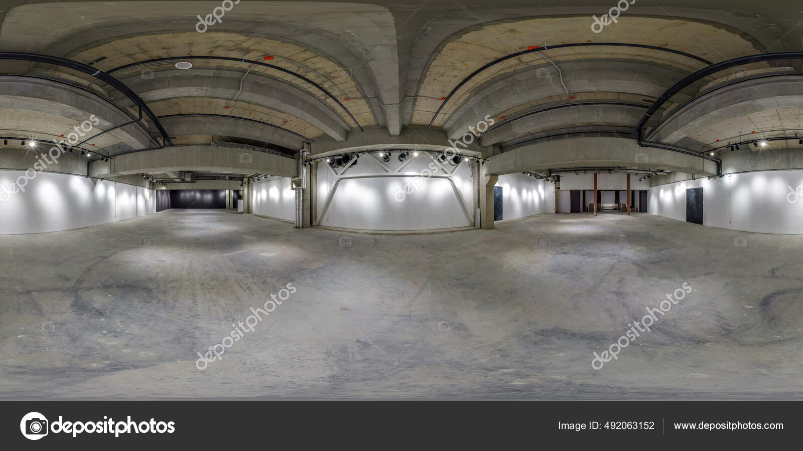
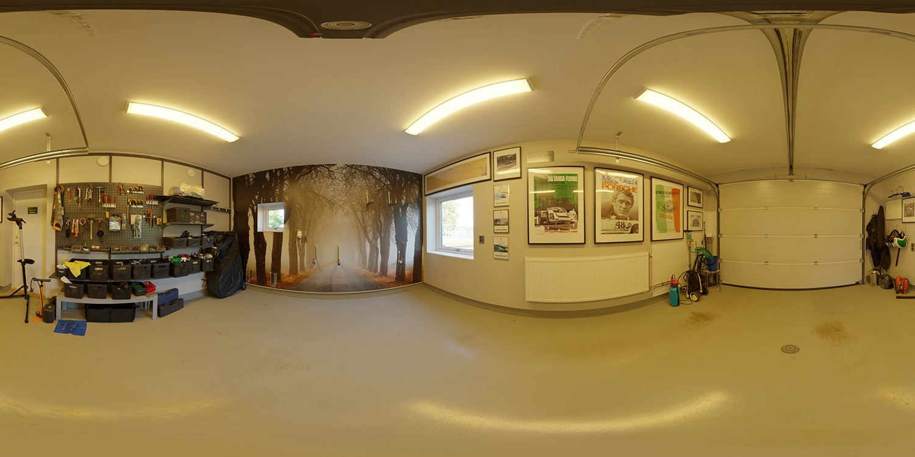
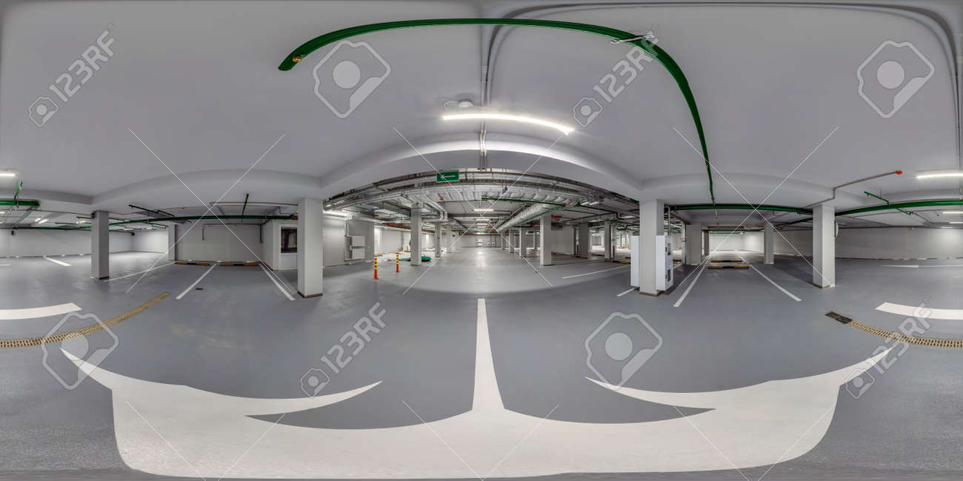
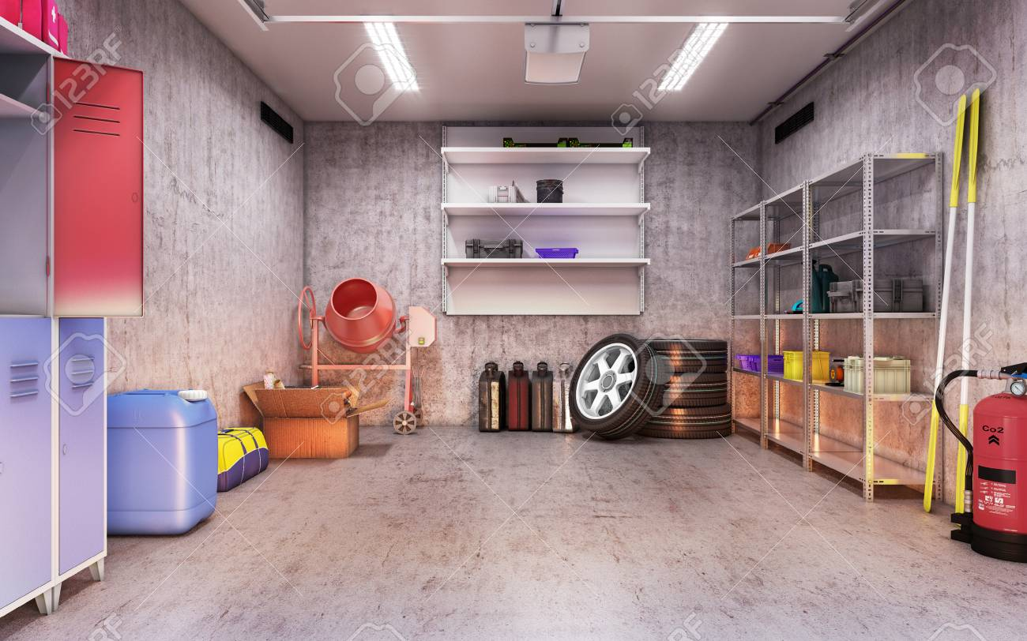
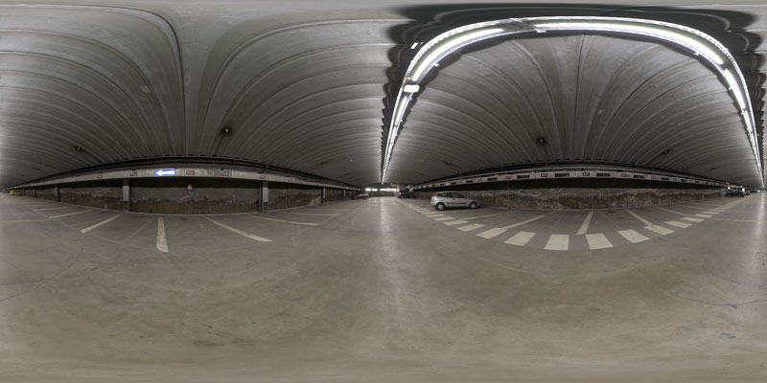
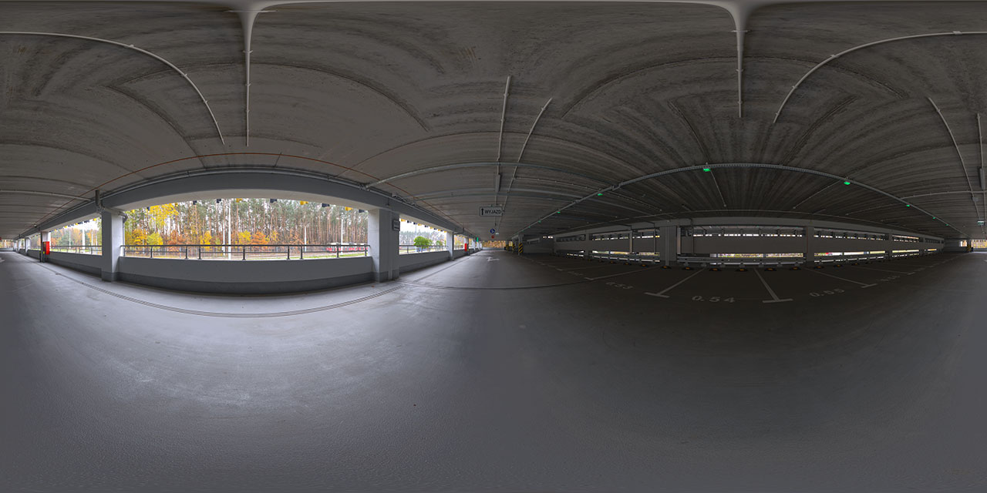
Here are some specific sources:
- Freepik – Has “Garage panorama” and “interior spherical panorama” images. Some free usage; check licence for commercial/portfolio use. (freepik.com)
- Vecteezy – Offers many “360 panorama garage” / “360 panorama interior” images. Free licence category available; check individual image details. (Vecteezy)
- Poly Haven – Free HDRI/360 indoor environments (good for editing into a scene). (Poly Haven)
- Paid but higher-quality option: Shutterstock – Has “360 garage” collections; cost applies but high resolution and rights-cleared. (Shutterstock)

⚠️ Licence & editing tips (important for portfolio use)
- Always check licence type: Some “free” images require attribution; others may not allow commercial use unless upgraded.
- For portfolio use, ensure the licence allows modification and commercial-/educational use.
- If you choose a free image but it’s generic (empty garage), you may want to edit it (e.g., insert an EV charger graphic) so it matches your EV-Charging scenario.
- Confirm image is truly equirectangular (2:1 aspect ratio, full 360°)? If not, you might need to stitch or adjust using panorama software (free tools like Hugin).
- When editing, ensure the resolution is high (e.g., 6000×3000 px or similar) to maintain quality in Storyline’s 360 viewer.

🛠 Which one I suggest for you and next step
Given your topic (Residential Garage EV Charger Setup), I recommend:
- Pick one free image from Vecteezy or Freepik that shows a typical garage interior (empty or with car) with good resolution.
- Then in Photoshop/GIMP: add an EV-charger unit graphic to a wall in the panorama (so that learners see the charger as part of the scene).
- Ensure the final image remains equirectangular, and export it as JPG (e.g., 6000×3000 px).
- Then import into Storyline as your 360° backdrop for hotspots.

If you like, I can identify and send you 3–5 specific downloadable image files (with direct links, sample thumbnails, resolution, licence terms) right now — we can pick the best for your build. Would you like me to do that?
Here are the exact search terms you should use to find proper 360° equirectangular images for your EV-Garage scenario. These keywords work on Pexels, Unsplash, Pixabay, Freepik, Vecteezy, Shutterstock, Adobe Stock, PolyHaven, Kuula, and even Google Images.

✅ BEST SEARCH TERMS FOR 360° EQUIRECTANGULAR IMAGES
Use these exact phrases:

Primary keywords (most accurate)
- “equirectangular garage”
- “360 equirectangular interior”
- “equirectangular panorama garage”
- “360 spherical panorama garage”
- “HDRI garage interior 360”
- “garage interior 360° panorama”
- “spherical panorama interior garage”
These guarantee the full 2:1 equirectangular format.

🔍 Keywords specific to EV-charging / workshop look
Even if they don’t show a charger, these give an environment you can edit:
- “garage workshop 360 panorama”
- “empty garage 360 panorama”
- “residential garage 360 panorama”
- “car garage 360 equirectangular”
- “mechanic garage 360 hdri”

🔍 Keywords for stock sites with HDRI/3D images
If you want extremely clean and editable images (from HDRI libraries):
- “garage hdri 4k”
- “indoor hdri equirectangular”
- “industrial interior hdri 360”
These give photorealistic 360° images often used in 3D rendering but perfect for Storyline.

🔍 If you want to browse ALL 360° images and filter manually:
Use:
- “equirectangular 360°”
- “360 panorama interior”
- “full spherical panorama”
Then filter results by:
- Interiors
- Rooms
- Workshops
- Garages

🧠 How to immediately know if an image is correct for Storyline
Look for these signs:

✔ Must be 2:1 ratio
Example:
6000 × 3000 px
8000 × 4000 px
4096 × 2048 px

✔ Must look like this shape:
A stretched “flat world map” look (wide and flat, distorted at top/bottom).

✔ Should mention these terms:
- equirectangular
- 360°
- spherical
- full panorama
- HDRI

✔ Should NOT be:
- Tiny little 360-viewers on webpages
- Rectangular photos shot with wide-angle lenses
- Partial panoramas (those do NOT work in Storyline)

🎯 Recommended fastest combination
If you want the best possible hit rate when searching:

👉 Use this exact string:
"garage interior equirectangular 360 hdri"
This gives the best real/3D garage environments that import perfectly into Storyline.

💬 Want me to fetch specific images for you?
I can now:
✓ Search across Freepik, Vecteezy, Polyhaven, and Unsplash
✓ Select 5 top candidates
✓ Verify licence
✓ Confirm the image is truly equirectangular
✓ Provide download links + which one fits your scenario best
Just say:
“Find me 5 images” or
“Find me images from free sources only”
And I’ll fetch them for you.
Ah—yes, let me clarify this very clearly because this is important for your Storyline project:

✅ Is EV Charging a Part of Residential Garage Installation?
YES.
What you are building is a training module for:

“Residential EV Charger Installation & Safety Inspection”
This means the EV charger is installed inside a residential garage (or on an external wall of the home).
This is a very common real-world scenario used by:
- Electricians
- EV charger installers
- Homeowners preparing for EV ownership
- Training programs in utilities and service companies
Your scenario (Option C) is exactly about:
✔ Installing a Level 2 home charger
✔ Checking the electrical panel
✔ Mounting the charger on a garage wall
✔ Routing conduit
✔ Ensuring safety clearances
✔ Testing (commissioning) the device
✔ Verifying cable condition, drainage, grounding, etc.
So yes — you’re absolutely in the correct direction.

❓ Are the 360° garage images relevant to residential EV charger installation?
Yes.
You need a 360° interior garage image because that is the typical real-world location where the EV charger will be installed.
Why garage interiors work:
- That is where home chargers are mounted (on the wall).
- Inspectors check:
  - electrical panel
  - breaker
  - cable routing
  - ground
  - heater proximity
  - water sources
  - floor drainage
- Vehicles park there and connect to the charger.
- It allows your learners to “walk around” the environment via a 360° scene.
So, the 360 garage panorama is not random —
it is the correct immersive environment for residential installation.

🔧 What you will do with the 360° garage image in Storyline
You will use it as your 360° base scene, then place hotspots on:

Example hotspot locations:
- Electrical Panel → “Is the breaker sized correctly?”
- Conduit Entry → “Is wiring routed safely?”
- Wall Mount Area → “Is the charger installed at correct height?”
- Ground Lug Area → “Is there proper bonding/grounding?”
- Heater/Appliance Zone → “Is there safe clearance?”
- Cable Storage Hook → “Is cable stored without damage?”
- Floor Area → “Any trip hazards or water exposure?”
- Vehicle position line → “Clearance OK?”
This replicates a real residential garage inspection.

🔍 Do you also need EV charger images?
Yes — you’ll insert the EV charger unit graphic on top of the 360° scene if the source garage image doesn’t already contain one.
Sources you can use:
- Freepik (EV charger PNG)
- Vecteezy
- PNGtrees (with attribution)
- Manufacturer images (as long as you attribute and avoid large copyrighted parts)
Or you can ask me and I’ll give you EV charger PNG elements to overlay.

📌 Summary (to remove confusion)
- The scenario you’re building = Residential EV charger installation
- The 360 image you must search for = residential garage interior equirectangular
- You will add the charger (PNG) into the scene
- Then build all your Storyline hotspots
- And use the checklist we extracted earlier
Everything fits perfectly.

If you want, I can do this next:

Option A — Find 5 perfect 360° garage images (free only) + download links

Option B — Find 3 EV charger PNG graphics to overlay

Option C — Show you how to blend the charger into the 360 image using free GIMP

Option D — Start building the 12 hotspot scripts
Just tell me A, B, C, D, or combination.
Great question — YES, everything we’ve been designing so far is specifically for four-wheeler EV (cars) residential charging installation.
Let me break down the details so you are 100% clear:

✅ Is the scenario for four-wheeler EVs?
Yes.
The “Residential EV Charger Installation & Setup” scenario we have been working on applies to Level 2 residential EV chargers used for electric cars (four-wheelers), such as:
- Tata Nexon EV
- MG ZS EV
- Hyundai Kona
- Mahindra XUV400
- Tesla Model 3 / Y
- BYD Atto 3
- Kia EV6
- BMW/Mercedes EVs
These vehicles commonly use AC wall-mounted home chargers (3.3 kW / 7.4 kW / 11 kW / 22 kW depending on country & home supply).

🔌 Why your project perfectly fits 4-wheeler EV installations
Residential car charging involves:

✔ Level 2 AC wall-mounted chargers
Placed:
- inside a garage
- or on the exterior wall of a house
- or in a designated apartment parking slot

✔ Electrical Panel Assessment
Four-wheeler chargers usually require
- 16A / 32A / 40A dedicated breaker
- RCD/RCBO protection
- proper grounding & bonding
- conduit routing

✔ Mounting height, cable management, and vehicle reach
Only matters for car-length charging cables, not bike/scooter chargers.

✔ Commissioning steps (AC EVSE control pilot testing)
This is standard for all Type 1 / Type 2 chargers used for 4-wheelers.
Hence, all the hotspot checks and storyboard pieces already align with car charger installations, not 2-wheeler chargers.

⚠️ Is this different from 2-wheeler EV charging?
Yes — very different.
Two-wheeler EV charging typically uses:
- Portable 5A/15A plug chargers
- Low-power wall sockets
- No fixed EVSE unit
- No need for dedicated panel upgrades
- No 360° inspection environment needed
So, everything we’re creating is NOT for 2-wheelers — it is correctly focused on four-wheelers.

🏡 Which environments fit 4-wheeler EV home charging?
These 360° scenes are ideal:

A. Residential Garage Interior (BEST MATCH)
Most realistic global scenario
-perfect for AC wall chargers
-perfect for hotspot inspections

B. Apartment Basement Parking Slot (SECOND BEST)
Common in India & Asia
-good alternative environment
-also realistic for fixed wall chargers

C. Home driveway wall-mounted charger (optional)
Outdoor but still residential
-useful as a second scene

🎯 So yes — choose a 360° image that fits a 4-wheeler parking area:
- Residential home garage (recommended)
- Apartment basement car parking slot
- House carport or driveway wall
Any of these are correct for car (four-wheeler) charging.

Next Step
Now that the EV type is confirmed as four-wheeler, would you like me to:

A — Find 5 perfect free 360° garage images for four-wheelers

B — Find 5 basement-parking 360° images (also for cars)

C — Provide both sets (10 images)

D — Move on to hotspot script creation
Just reply with A / B / C / D.

